Swainswick Church School Pupil premium Strategy Statement 2022-2023
This statement details our school’s use of pupil premium (and recovery premium for the 2021 to 2022 academic year) funding to help improve the attainment of our disadvantaged pupils. It outlines our pupil premium strategy, how we intend to spend the funding in this academic year and the effect that last year’s spending of pupil premium had within our school. Our funding allocation will focus on three core areas:
- Teaching
- Targeted academic support
- Wider strategies

Our approaches will be monitored and reviewed to analyse impact on outcomes for disadvantaged pupils.

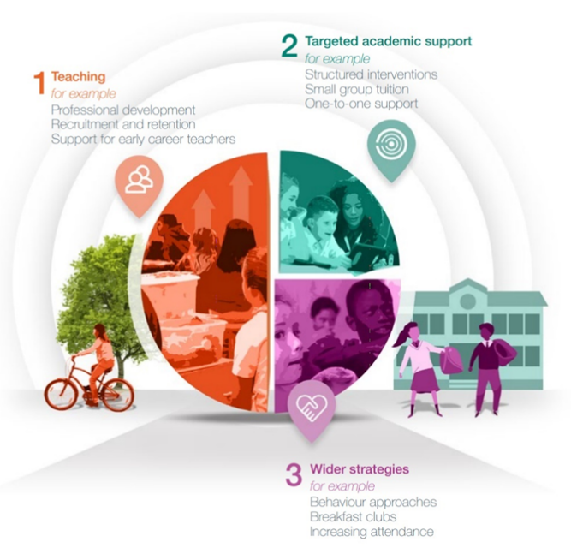

School overview
Total number of pupils in school | 80
Proportion of disadvantaged pupils | 5% 4/80
Proportion of disadvantaged pupils who have SEND | 25% 1/4
Academic year/years that our current pupil premium strategy plan covers (3 year plans are recommended) | 3
Publish date | October 22
Review date | July 23
Statement authorised by | Grant Swarbrooke – HT  Shannon Carr-Shand – Chair of Governors
Pupil Premium lead | Grant Swarbrooke
Governor lead | Shannon Carr-Shand
Funding Overview
Detail | Amount
Pupil premium funding allocation this academic year | £ 7,984
Recovery premium funding allocation this academic year | £ 2,000
Pupil premium funding carried forward from previous years (enter £0 if not applicable) | £ 0
Total budget for this academic year  If your school is an academy in a trust that pools this funding, state the amount available to your school this academic year | £ 9,984

Part A: Pupil Premium Strategy Plan
Statement of Intent – Over 3 Years
At Swainswick Church School we hold the child at the centre of all our work, so they can be the best version of themselves:
- All children are unique, and we work to ensure that all achieve their very best
- We look at the holistic child
- We value everyone’s views and ideas to gain a shared understanding of a child’s needs
- We work together: children, parents/carers, school staff, specialists
- All leader in our schools are leaders of SEND and Pupil Premium
- All teachers are teachers of SEND and Pupil Premium.

Challenges

This details the key challenges to achievement that we have identified among our disadvantaged pupils.
Challenge | Detail of challenge
1 | Several children find it difficult to emotionally regulate and this means they are not always ready to learn. (This group also includes those who are high ability and pupils with SEND).
2 | Children identified as Pupil Premium in EYFS, KS1 and KS2 who did not meet expected standard in phonics and number bonds/times tables due to limited oracy and less opportunities to apply these skills at home.
3 | Some pupils struggle in their confidence and resilience as speakers and readers, therefore speaking and reading in public with confidence and expression can be limited.
4 | Several children struggle in confidence and general resilience when challenged with new experiences - where they are asked to step out of their comfort zone.
5 | Whilst the attendance for many PP students is good, we have some children who are persistently absent or have attendance below 95/90%.

Intended Outcomes
This explains the outcomes we are aiming for by the end of our current strategy plan, and how we will measure whether they have been achieved.
Challenge | Intended outcome | Success criteria
1 | Children can emotionally regulate and are therefore ready to learn. | Thrive assessment progress.
2 | Identified children continue to make expected progress in phonics.  Increased oracy with opportunities to apply these skills in school and at home. | Phonics assessment demonstrates expected progress by the end of KS1.
3 | Identified children continue to make expected progress in number bonds and times tables.  Increased oracy with opportunities to apply these skills in school and at home. | Number bonds and times tables assessment demonstrates expected progress by the end of KS1.
4 | Pupils build confidence and resilience as speakers and readers in 1:1, group, and public settings. | Speaking and reading in public.
5 | Children build confidence and general resilience when challenged with new experiences – and can step out of their comfort zone. | Residential success  Demonstrating a growth mindset and grasp new challenges.
6 | Identified pupils do not have persistent absent and therefore academic progress is not affected. | Attendance is not below 95/90%.

Activity in this academic year 2022-2023
This details how we intend to spend our pupil premium (and recovery premium funding) this academic year to address the challenges listed above
Teaching
Budgeted Cost: £3,484
Priority | Activity | Challenge number
Ensure all relevant staff have received high quality phonics training (Little Wandle Phonics) and are skilled in the delivery of systemic synthetic phonics.  (£1,000)  (£500) | - Subscribe and embed the use of Little Wandle phonics scheme across EYFS, KS1 and KS2 catch up pupils  - 1:1 Phonics CPD and monitoring for TA | 2,3
Ensure all staff are skilled in the assessment of pupils learning in phonics (Little Wandle Phonics) , reading and writing.  (£1,314) | - Lead inset and staff meeting sessions on the use of assessment in phonics and moderation of writing to ensure teaching addresses specific weaknesses in PP pupils writing. This being evidence in the Closing the Gap document.  - Work in partnership with SENCO and teachers to plan, implement and review a phonic catch-up programme | 2,3
Ensure all relevant staff have received high quality x tables and number bonds training (Count on Provision) from mathematics specialist – Liz Thomas  (£670) | - Use step counting for times tables daily as modelled  - Weekly use of tell me everything you can to support recall of previous knowledge and retention of new knowledge.  - Y5/6 to also use the fluency grids to support mental calculation facts outside known x facts e.g., if I know 6 x 6 then I can do 6 x 60 and I can use my 6 x table to solve 3618 divide by 6. | 2,3

Targeted Academic Support
Budgeted Cost: £3,000

Priority | Activity | Challenge number(s) addressed
PP leader, SENCO and teachers work together to use assessments to accurately identify which pupils require a structured programme of interventions.  (£300) | - Provision map and interventions  - SENCO and teacher collaboration with completion of Closing the Gap plan/document  - Pupil progress meetings 3 times a year to discuss impact of interventions. | 1,2,3
TA to deliver specific phonics and oracy interventions in EYFS/KS1 and KS2 pupil catch up  (£400) | - Using phonics assessments, select pupils to receive a targeted, phonic intervention programme.  - Purchase/make specific phonics resources for this group and for children to take home.  - Deliver a series of virtual phonics sessions via Teams, to enable parent and child to learn together. | 1,2,3
Targeted intervention for specific pupils through the Catching up Recovery Programme  (£2,300) | - School Led Tutoring Programme (teaching staff) to be implemented for identified pupils  - Embedding of three-way partnership between tutor, school, and home. | 1,2,3

Wider Strategies (for example, related to behaviour, attendance, well-being)
Budgeted Cost: £3,500
Priority | Activity | Challenge number(s) addressed
Develop package of SEMH support and staff expertise  (£2500) | - Employ Thrive practitioner who provides weekly session for identified pupils – building self-esteem, reflection and resilience.  - Hold termly whole staff meetings – monitoring identified pupils and impact of thrive interventions  - Employ lunchtime mentor for identified pupils – monitor independent activities and support when required  - Provide lunchtime sports clubs | 4,5
Ensure all children have access to extra-curricular activities, broadening their experiences and therefore increasing confidence, independence.  (£1000) | - Provide lunchtime sports and coaching clubs  - Enriching opportunities through school trips and school visits should be experienced by all pupils including pp. This will enable positive experiences outside of the school setting to occur.  - Enable all pupils to participate on residential trips | 4,5
Total budgeted cost: £9,984

Part B: Review of outcomes in the previous academic year 2021-2022

Pupil premium strategy outcomes (Teacher Assessed)
This details the impact that our pupil premium activity had on pupils in the 2021 to 2022 academic year.
In identifying priorities, school leaders will take account of a wide range of information about the learning of disadvantaged pupils in informing them about the barriers to future attainment and progress. Due to COVID-19, performance measures have not been published for 2020 to 2021, and 2020 to 2021 results will not be used to hold schools to account.
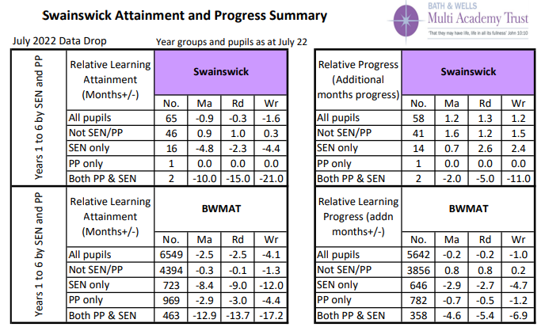

Review of expenditure 2021 - 2022
- Teaching
Outcomes and Impact Include impact on pupils not eligible for PP, if appropriate | Lessons learned  (and whether you will continue with this approach) | Cost
- Through subscribing and embedding the use of Little Wandle phonics scheme across EYFS, KS1 and KS2 catch up pupils – 91% of pupils passed the Y1 phonics screening.  - Voice 21 CPD in oracy evidence more identified pupils perform with confidence across the academic year – Assemblies, Class discussion, Presentations, Whole School Performances | - To adopt the rigorous approach in phonics and adapt to number bonds and x tables. This included in SDP  - To continue with Voice 21 Oracy provision | £3022
- Targeted Academic Support
Outcomes and Impact Include impact on pupils not eligible for PP, if appropriate | Lessons learned  (and whether you will continue with this approach) | Cost
Through PP leader, SENCO and teachers working together, assessments where accurately identify enabling structured programmes of interventions to be implemented.  - Provision map and interventions and close monitoring enabled pupils to make progress in identified areas. SENCO and teacher collaborations were completed and evidenced in the Closing the Gap plan/document. This resulting in accelerated progress in Y6 SATS for identified pupils  - Through subscribing and embedding the use of Little Wandle phonics scheme across EYFS, KS1 and KS2 catch up pupils – 91% of pupils passed the Y1 phonics screening.  - Targeted intervention for specific pupils through the Catching up Recovery Programme | TA to deliver specific phonics and oracy interventions in EYFS/KS1 and KS2 pupil catch up  - To adopt the rigorous approach in phonics and adapt to number bonds and x tables. This included in SDP | £4000
- Wider Strategies
Outcomes and Impact Include impact on pupils not eligible for PP, if appropriate | Lessons learned | Cost
- Through Employing a Thrive practitioner, who was able to provide weekly session for identified pupils – we saw a significant impact on self-esteem, reflection and resilience.  - Through holding termly whole staff meetings – all staff were aware and able to monitor identified pupils.  - Through employing a lunchtime mentor for identified pupils – positive, social, and active lunchtime were evidenced for identified pupils.  - Through lunchtime sports clubs, pupils were empowered active and social.  - Through enriching opportunities through school trips and residentials, pupil were able to grow considerable – building resilience and growth mindset. | A positive approach that will be continued and built upon.  To increase residential type activities into forest school provision – team building challenges on site. | £4852

Externally provided programmes
Please include the names of any non-DfE programmes that you purchased in the previous academic year. This will help the Department for Education identify which ones are popular in England
Programme | Provider

Use this space to provide any further information about your pupil premium strategy. For example, about your strategy planning, or other activity that you are implementing to support disadvantaged pupils, that is not dependent on pupil premium or recovery premium funding.

