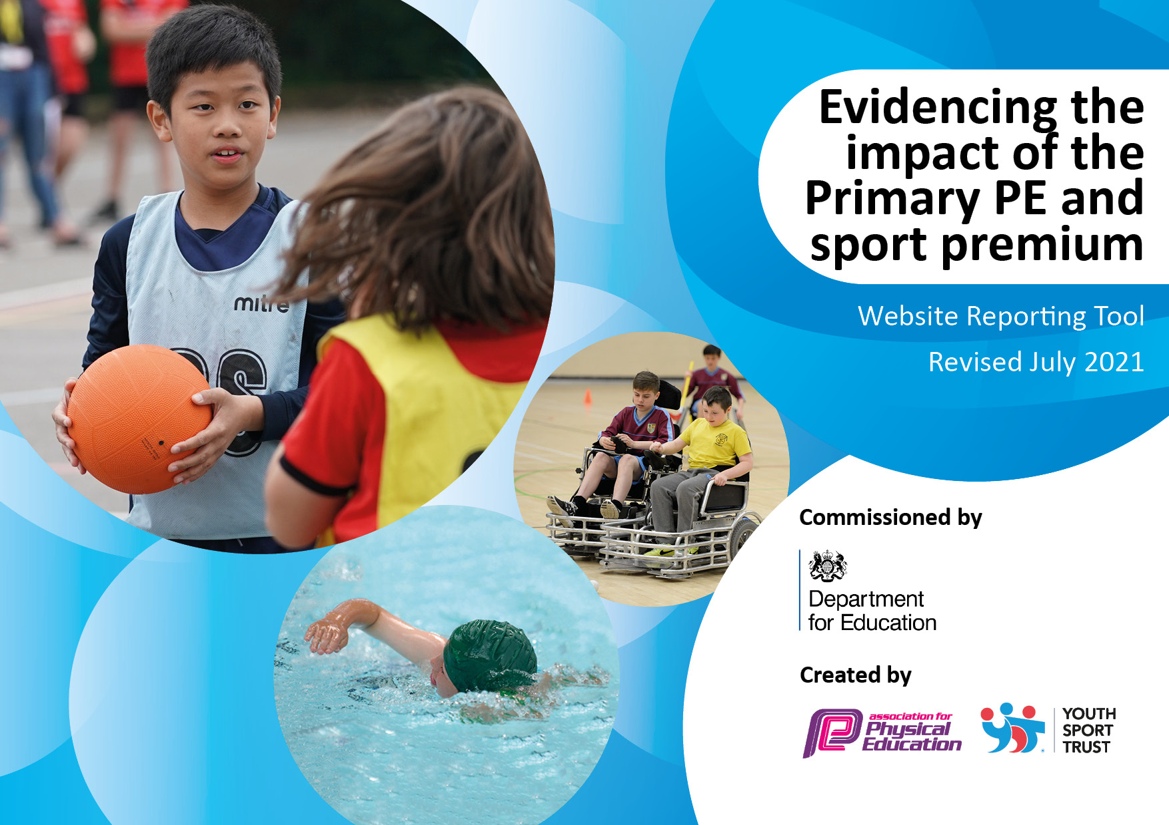
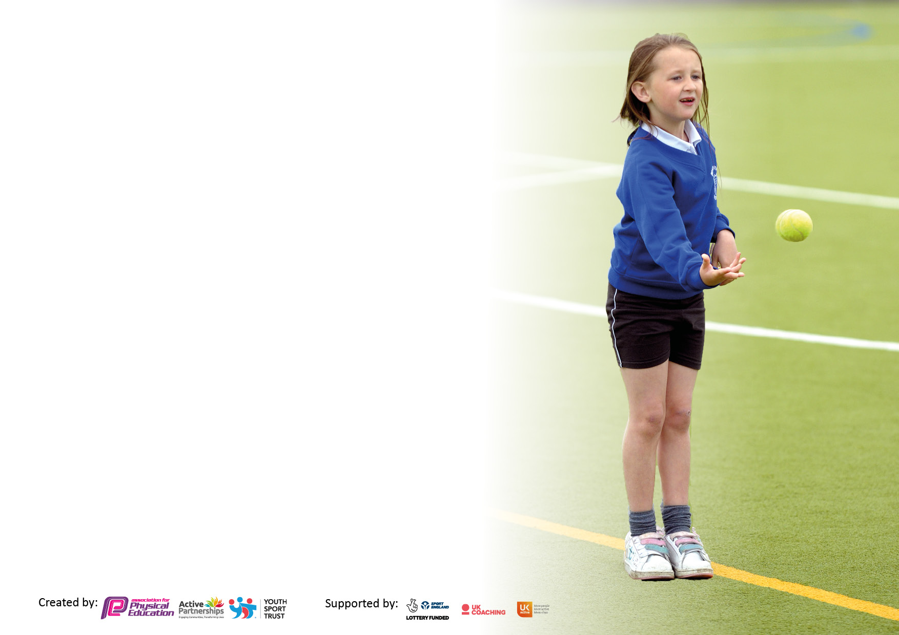

It is important that your grant is used effectively and based on school need. The Education Inspection Framework makes clear there will be a focus on ‘whether leaders and those responsible for governors all understand their respective roles and perform these in a way that enhances the effectiveness of the school’.

Under the Quality of Education Ofsted inspectors consider:
Intent - Curriculum design, coverage and appropriateness
Implementation - Curriculum delivery, Teaching (pedagogy) and Assessment
Impact - Attainment and progress

To assist schools with common transferable language this template has been developed to utilise the same three headings which should make your plans easily transferable between working documents.

Schools must use the funding to make additional and sustainable improvements to the quality of Physical Education, School Sport and Physical Activity (PESSPA) they offer. This means that you should use the Primary PE and sport premium to:

- Develop or add to the PESSPA activities that your school already offer
- Build capacity and capability within the school to ensure that improvements made now will benefit pupils joining the school in future years
- The Primary PE and sport premium should not be used to fund capital spend projects; the school’s budget should fund these.

Pleasevisitgov.ukfortherevisedDfEguidanceincludingthe5keyindicatorsacrosswhichschoolsshoulddemonstrate animprovement.Thisdocumentwillhelpyoutoreviewyourprovisionandtoreportyourspend.DfEencouragesschools to use this template as an effective way of meeting the reporting requirements of the Primary PE and sport premium.

We recommend you start by reflecting on the impact of current provision and reviewing the previous spend.

Schools are required to publish details of how they spend this funding, including any under-spend from 2019/2020, as well as on the impact it has on pupils’ PE and sport participation and attainment. All funding must be spent by 31st July 2022.

We recommend regularly updating the table and publishing it on your website throughout the year. This evidences your ongoing self-evaluation of how you are using the funding to secure maximum, sustainable impact. Final copy must be posted on your website by the end of the academic year and no later than the 31st July 2021. To see an example of how to complete the table please click HERE.
Created by: Supported by:

Details with regard to funding
Please complete the table below.

Total amount carried over from 2021/2022 | £0
Total amount allocated for 2022/23 | £16630
How much (if any) do you intend to carry over from this total fund into 2023/24? | £0
Total amount allocated for 2022/23 | £16630
Total amount of funding for 2022/23. To be spent and reported on by 31st July 2023. | £16630
Swimming Data
Please report on your Swimming Data below.

Meeting national curriculum requirements for swimming and water safety.

N.B. Complete this section to your best ability. For example you might have practised safe self-rescue techniques on dry land which you can then transfer to the pool when school swimming restarts.
Due to exceptional circumstances priority should be given to ensuring that pupils can perform safe self rescue even if they do not fully meet the first two requirements of the NC programme of study
What percentage of your current Year 6 cohort swim competently, confidently and proficiently over a distance of at least 25 metres?  N.B. Even though your pupils may swim in another year please report on their attainment on leaving primary school at the end of the summer term 2021.  Please see note above | %
What percentage of your current Year 6 cohort use a range of strokes effectively [for example, front crawl, backstroke and breaststroke]?  Please see note above | %
What percentage of your current Year 6 cohort perform safe self-rescue in different water-based situations? | %
Schools can choose to use the Primary PE and sport premium to provide additional provision for swimming but this must be for activity over and above the national curriculum requirements. Have you used it in this way? | No

Action Plan and Budget Tracking
Capture your intended annual spend against the 5 key indicators. Clarify the success criteria and evidence of impact that you intend to measure to evaluate for pupils today and for the future.

Academic Year: 2022/23 | Total fund allocated:£16630 | Date Updated: March 2023
Key indicator 1: The engagement of all pupils in regular physical activity – Chief Medical Officers guidelines recommend that primary school pupils undertake at least 30 minutes of physical activity a day in school |  |  |  | Percentage of total allocation:
 |  |  |  | 94%
Intent | Implementation |  | Impact
Your school focus should be clear what you want the pupils to know and be able to do and about  what they need to learn and to  consolidate through practice: | Make sure your actions to achieve are linked to your intentions: | Funding allocated: | Evidence of impact: what do pupils now know and what can they now do? What has changed?: | Sustainability and suggested next steps:
Staff have an understanding of the impact on pupil’s learning and health of Daily Physical Activity.  The children will become engaged in a wide range of physical play activities through sports play. Children have the opportunity to engage in organised sports activities at lunchtime though the provision of a sports coach.  Pupils have an understanding of the impact on learning and health of Daily Physical Activity – aware of heartbeat.  Regular brain/fitness breaks during curriculum time  Bikes for EYFS pupils | PE specialists to teach all classes the importance of physical activity.  Sports coaches lead sport activity during lunchtime  All pupils to know how to do a warm up and to be able to show a ‘heartbeat puppet’.  Go noodle and other activity websites used in curriculum time. | £7800 BR  & £2000 MW  £5844  Progressive Sports | Across the year, children from Years R to 6 have engaged with lunchtime sports and activities ranging from football to dodgeball to multisports.  Pupil play and team sports has vastly improved.  All pupils can identify where their hearts are and demonstrate activities to get it beating faster and harder. | Adapt sports play sessions to include the use of all outdoor spaces and offer a wider variety of activities.  Whole school to use stopwatches for 5 min or 1 mile runs.
Key indicator 2: The profile of PESSPA being raised across the school as a tool for whole school improvement |  |  |  | Percentage of total allocation:
 |  |  |  | 1.4%
Intent | Implementation |  | Impact
Your school focus should be clear what you want the pupils to know and be able to do and about  what they need to learn and to  consolidate through practice: | Make sure your actions to achieve are linked to your intentions: | Funding allocated: | Evidence of impact: what do pupils now know and what can they now do? What has changed?: | Sustainability and suggested next steps:
Make sure Swainswick has all the equipment it needs for PE lessons and playtimes | Staff, coaches, Lunchtime supervisors and pupils identify what equipment is needed. | £231 | PE has a member of teaching staff driving it forward ensuring that it keeps a very high profile  PE sessions and lunchtime and after-school clubs are suitably resourced so that children have been able to take part. | Rotate teacher leading PE to prevent gender/age stereotyping  Identify short and middle-term goals for equipment update.  Pupil voice to convene to discuss what equipment would help improve playtimes/PE

Key indicator 3: Increased confidence, knowledge and skills of all staff in teaching PE and sport |  |  |  | Percentage of total allocation:
 |  |  |  | 2.6%
Intent | Implementation |  | Impact
Your school focus should be clear | Make sure your actions to | Funding | Evidence of impact: what do | Sustainability and suggested
what you want the pupils to know | achieve are linked to your | allocated: | pupils now know and what | next steps:
and be able to do and about | intentions: |  | can they now do? What has
what they need to learn and to |  |  | changed?:
consolidate through practice:
Scheme of Work that PE staff and sports coaches can follow to map progression for each Year group. | Getset4PE | £440 | Staff more confident with easy-to-use curriculum planning | PE lead to observe teachers leading their PE lessons to check and support understanding and delivery, especially skill acquisition.
Key indicator 4: Broader experience of a range of sports and activities offered to all pupils |  |  |  | Percentage of total allocation:
 |  |  |  | 2%
Intent | Implementation |  | Impact
Your school focus should be clear | Make sure your actions to | Funding | Evidence of impact: what do | Sustainability and suggested
what you want the pupils to know | achieve are linked to your | allocated: | pupils now know and what | next steps:
and be able to do and about | intentions: |  | can they now do? What has
what they need to learn and to |  |  | changed?:
consolidate through practice:
Additional achievements:  Take part in wider range of sport and physical activity  Yr 6 to trampoline park in May 23  Yr 4/5/6 went to Rugby Festival October 22 | Links to Avon Rugby Club | Transport and entry to events  £315 |  | Talent Tuesday  Real and virtual talent competitions where we can showcase range of skills.  If inspired invite external activity leaders to share their skills.

Key indicator 5: Increased participation in competitive sport |  |  |  | Percentage of total allocation:
 |  |  |  | 0%
Intent | Implementation |  | Impact
Your school focus should be clear | Make sure your actions to | Funding | Evidence of impact: what do | Sustainability and suggested
what you want the pupils to know | achieve are linked to your | allocated: | pupils now know and what | next steps:
and be able to do and about | intentions: |  | can they now do? What has
what they need to learn and to |  |  | changed?:
consolidate through practice:
Dodgeball Club fixture with St John’s  Inter-school fixtures | KS2 pupils invited to dodgeball fixture  Some pupils who describe themselves as non-sporty took part in the dodgeball matches | £0  Parents to transport children to events | Some pupils have recorded how with practise they have improved their personal best scores. | Pupils sign up for sports fixtures they may be interested in e.g swimming, football etc so viability of team is known and can be prepared in advance of festivals.  Explore further inter school competitions – football and netball in summer terms

Signed off by
Head Teacher:
Date:
Subject Leader:
Date:
Governor:
Date:

