Mathematics

Number: Place Value

Sorting objects.

Counting objects.

Comparing objects.

Ordering objects.

Ordering numbers.

Ordinals.

The Number Line.

Number: Addition and Subtraction

Symbols.

Number bonds to 10.

Finding a part.

Part whole models.

Counting back and finding the difference.

Geometry

2D and 3D shapes

Repeating patterns

Science

Chemistry

Marvellous Materials

Identifying and sorting common materials and their properties.

Recognising that objects can be made of several different materials.

Finding out about waterproof materials.

Testing the properties of materials.

English

Phonics

To revisit and consolidate Phase 3 and

Phase 4 Phonics.

To introduce Phase 5 Phonics.

Handwriting

Correct formation and orientation of all letter shapes.

Reading and Writing

Writing labels, lists and captions.

Information writing about homes around the world.

Making information posters.

Story Making Activities based on the Traditional Tale: The Three Little Pigs.

Poetry

Using our senses.

Computing

Technology around us

J2 Code- Exploring Art, Coding and Animation

RE

Special me

Who are we?

Harvest Celebrations.

PSHE

Jigsaw; Being Me In My World

Our Homes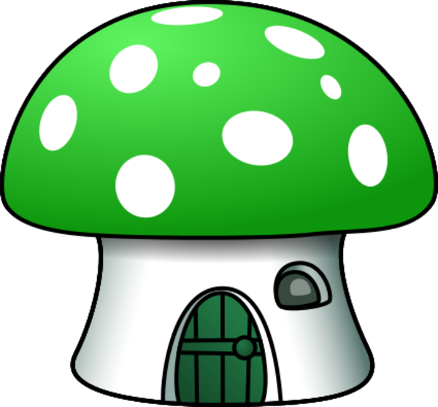

Year 1

Term 1

2015

**Computing**

**Programming:**

J2code: coding

**Technology in our lives:**

Internet research .

E- safety

**Handling data**

Taking photos of our environment.

Geography

Who Lives Here?

Comparing homes around the world.

The lives and homes of the Inuit people and the Yanomami people of the Amazon.

A nomadic way of life.

Living underground.

Art

Mark Making

Magic Painting.

Painting with a paintbrush.

Mark making and materials (rubbings).

Creating art in the style of Paul Klee

**Art**

Self Portraits in paint.

Sketches and charcoal drawings of St. Mary’s Church.

Paper skills: weaving, cutting, folding.

Fabric: sewing, stuffing and knotting techniques.

**Art**

Self Portraits in paint.

Sketches and charcoal drawings of St. Mary’s Church.

Paper skills: weaving, cutting, folding.

Fabric: sewing, stuffing and knotting techniques.

**Geography**

Do you know where you live?

Travelling to school; creating picture maps of our journeys.

Comparing rural and urban areas.

PE

Balancing and Stretching.

Throwing and catching

balls and bean bags.

Running in and around the playground spaces- changing direction and body shapes.

Learning playground games.

**Art**

Self Portraits in paint.

Sketches and charcoal drawings of St. Mary’s Church.

Paper skills: weaving, cutting, folding.

Fabric: sewing, stuffing and knotting techniques.

Music

Exploring Sounds

Listening to percussion sounds.

Sorting percussion sounds.

Listening to and creating repeating sounds.

Responding through movement.

* **Music**
* Percussion sounds.
* Responding through movement.
* Keeping the steady beat.
* Listening to and repeating sounds.
* Long and short sounds.
* High and low sounds.

Other

Reading is Magic Festival.

OO