School Admission Arrangements
2023/24 School Year

For Bath and Wells Multi Academy Schools located in the
Bath and North East Somerset Local Authority Area

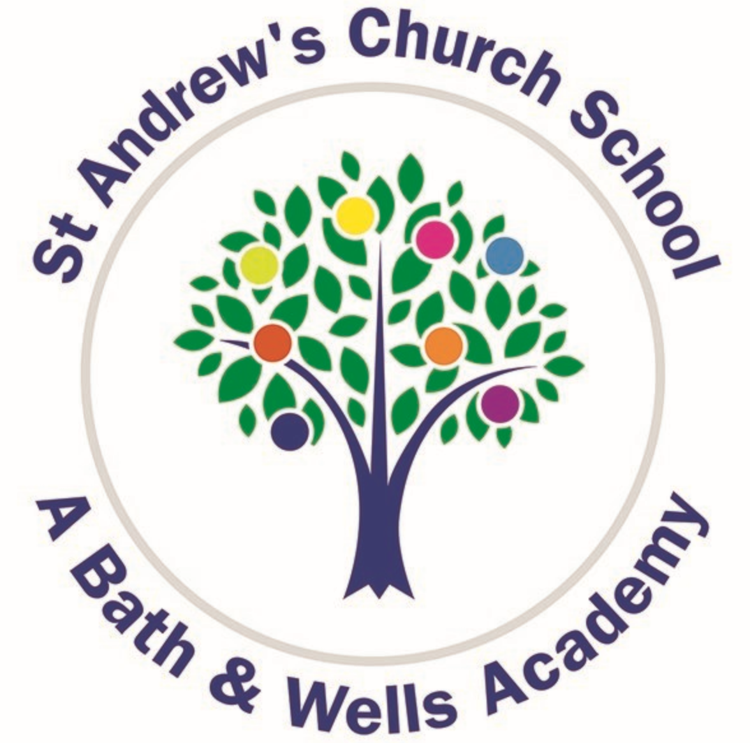

Introduction

The Bath and Wells Multi Academy Trust (The Trust) comprises a family of fully inclusive schools seeking to provide the highest standard of education for primary age children. Geographically the schools are spread across three local authority areas: Somerset, Bath and North East Somerset and North Somerset. These Admission Arrangements refer to The Trust’s schools that are located in the Bath and North East Somerset Local Authority area and apply equally for all the incorporated schools with the exception of ‘oversubscription criteria’ which can differ from school to school and individual contact information.

These Admission Arrangements comply with the requirements of the 2021 School Admissions Code and the 2012 School Admission Appeals Code issued by the Department for Education under Section 84 of the School Standards and Framework Act 1998. Concerns relating to statutory compliance or the fairness and equality of local policy/practice, may be raised with The Trust. If the matter cannot be resolved locally, a complaint may be lodged with the Office of The Schools Adjudicator (OSA):

Bath and Wells Multi Academy Trust | Email: Enquiries@bwmat.org | Tel: 01749 372700
The Office of The Schools Adjudicator | Website: www.gov.uk/government/organisations/office- of-the-schools-adjudicator

The Trust will republish these Admission Arrangements on an annual basis unless changes are proposed in which case a further public consultation will be carried out. Day to day admission enquiries and decisions should be made directly to the school concerned.

Contents:
- Important General Information
2.0 Starting School
3.0 Changing school In-Year
4.0 Lodging an appeal
Appendix A: Oversubscription Criteria and school details
Appendix B: Catchment Maps
Appendix C: In-Year Application Form
Appendix D: Supplementary Information Forms (SIF)

1.0 Important General Information

1.1 A person with legal responsibility for the child concerned may submit a school admission application on behalf of that child for any United Kingdom state funded school. The child must, at the time of application, be a UK citizen or have European Economic Area Citizenship, or hold an appropriate Home Office Visa entitling residency in the United Kingdom.

NOTE:
The Trust will treat applications for children coming from overseas in accordance with European Union law or Home Office rules for non-European Economic Area nationals.

This is the most recent guidance which takes account of the post-Brexit immigration system:
https://www.gov.uk/guidance/schools-admissions-applications-from-overseas-children

1.2 The admissions authority will refuse an admission application where a further admission would ‘prejudice the efficient delivery of education or the efficient use of resources ‘or where the admission would breach the statutory infant class size (ICS) Limit, resulting in an infant class of more than 30 children to one qualified teacher for part or all of the school day.’ Children who are formally refused admission will be entered onto a waiting list for the required year group. This will be maintained by the school concerned until the end of the school year and then shut down. Names on waiting lists are held strictly in ranked order according to the child’s compliance with the published oversubscription criteria and each time a name is added, the waiting list will be re-ranked. If a place becomes available this will be offered for the child ranked highest on the waiting list at that time. A child’s name will be removed from the waiting list if a place is offered and accepted or offered and declined, or the parent requests in writing, that the school removes his/her child’s name.

1.3 Admission applications for some Trust schools will require the completion of a Supplementary Information Form (SIF) in order to prove qualification against one or more of the oversubscription criteria which apply for the school concerned. The oversubscription criteria are set out in ‘Appendix A’ of this document and applicable SIFs in ‘Appendix D”. The SIF can also be found on the appropriate School websites.

1.4 For admission purposes, the Admission Authority will consider the home address to be: The address at which the child concerned is living at the time of application, for more than 2.5 school days per week, with a person who has legal responsibility for this child. This home address must be clearly stated on the application form. Where the child will be moving to a new home address and the applicant wishes this to be taken into account, one of the following documents must be made available in conjunction with the admission application:

- A legal ‘exchange of contract’ which confirms the purchase of the child’s new residence
- A formal tenancy agreement (minimum six month term) signed and dated by the applicant and the Landlord for the property
- Where the child will be living at an address other than the parental family home, for more than 2.5 school days per week (for example; with an extended family member, or in emergency or other public accommodation): A formal written letter, signed and dated by the person responsible for the address in question. This must explain the living and care arrangements for the child and state how long these arrangements are expected to remain in place.
- For Children of UK service personnel with a confirmed posting to the area or Crown servants returning from overseas: An official letter confirming a relocation date and Unit postal address or quartering area address.

NOTE:
The Trust reserve the right to seek further documentary evidence to support any claim of residence which could include contacting the estate agent, solicitor, landlord or relevant professional. A representative of the Trust may carry out a home visit/s without prior notice to verify a pupil’s home address.

1.5 The oversubscription criteria (Appendix A) include an admission priority for children with a sibling attending the school at the time of application (e.g. the date that each application is made).

1.6 If a parent wishes a sibling connection to be taken into account, the sibling’s details must be provided on the admission application form. The sibling must be living at the same permanent home address (see section 1.4 for home address definition) for the majority of his/her school time (more than 2.5 school days per week) within the same family unit and at the same home address.

1.7 The Published Admission Number or admission limit will be exceeded, where necessary, in order that multiple birth siblings of the same family (twin, triplet etc.) can all be offered places, where otherwise one or more of these children would be refused. After the over-subscription criteria has been applied, if children of multiple births (twins and triplets) are tied for the final place within the Published Admission Number, those siblings will be admitted over PAN.

1.8 If an admission application is found to include false or misleading information, the application will initially be withdrawn and the applicant informed. The application will then be considered again using the correct verified information.

2.0 Starting School for the first time in September 2023

Applicants should refer to 2023 ‘Apply for a primary school place (Reception)’ information published by Bath and North East Somerset Local Authority from 12 September 2022. This explains the application procedure in detail and the time frame for submitting applications and how to appeal a decision to refuse a place at the preferred school.

Bath and North East Somerset Local Authority | Email: admissions_transport@bathnes.gov.uk | Tel: 01225 394312

NOTE:
Children can lawfully start school for the first time in the September following their 4th birthday and, where a place is offered may attend full time from day one or on a part time basis until compulsory school age is reached on a prescribed date during the term following their fifth birthday. Where compulsory school age has not yet been reached, the child’s entry to school may be deferred until later in the school year but not beyond compulsory school age or the start of the last term in that school year. All the Trust’s schools operate a six-term year.

A child born between 1 April and 31 August is described as ‘summer born’ and entry to school for this child may be lawfully delayed for one year where this is considered by the applicant to be in the child’s best educational interests. The applicant must still apply for a place in September 2023, but can explain the intention to delay entry until the following September. This could be on the basis of a ‘retained’ Reception place or the submission of a later In-Year application for Year 1.

2.1 Applicants must complete the ‘Common Application Form’ issued by the home Local Authority (LA) and submit this according to published procedure before 15 January 2023. Applications submitted after this deadline will be considered ‘late’ and will not be processed until on time applications have been administered by which time a place at the preferred school may no longer be available.

2.2 Places will be offered by the Admission Authority in the Reception Year at the preferred school up to the Admission Number published for the 2023 school year. The published Admission Number (PAN) is set according to the resources available and the need to maintain the size of infant classes within the requirements of statutory Infant Class Size legislation (a maximum of 30 children per teacher unless a child qualifies as a permitted exception admission in accordance with section 2.16 of the 2021 School Admissions Code). If fewer applications are received than PAN, every applicant will be offered a place for their child without condition. If more applications are received than PAN, the Admission Authority will apply oversubscription criteria in order to rank all the applications and identify a priority for the offer of places up to PAN.

2.3 Application decisions will be notified by the home local authority on 16 April 2023 to all applicants who submitted an ‘on time’ application.

3.0 Changing School In-Year

3.1 The applicant may apply for a child within his/her care to change school during any academic year, or within six school weeks of that academic year commencing. The In-Year Application Form which can be found on the School website or provided as a paper copy by the School Office, must be completed and returned directly to the school. If the application is being made for a child from a Service family or the parent of the child is a Crown Servant returning from overseas, the application may be submitted more than six school weeks in advance of the place being required, providing an official letter is submitted with the application, which sets out a relocation date and confirms a Unit postal address or quartering area address.

Note:
Children who have an Education Health and Care Plan agreed or already in place may not change school without the parent/carer first discussing the desire for a change of school with the local authority that issued the care plan.

3.2 The applicant may apply for the child to join the year that he/she feels is most appropriate for his/her educational needs. In most cases, this will be the year that is relatively (chronologically) correct for the child’s age. Where this is not the case and the preferred year is full, further consideration will be given to whether a place can be made available within the relative (chronological) age year. The right of appeal will apply where a place cannot be offered in this year.

3.3 The Trust delegates In-Year admission decisions to a sub-group of the school governors (The Admissions Committee) and this committee will issue a decision to the applicant in writing within ten school days of receipt of a completed and signed In-Year Admission Application Form.

3.4 A place will be offered for the child concerned in the preferred year, where a further admission would not ‘prejudice the efficient delivery of education or the efficient use of resources or the admission would not breach the statutory Infant Class Size Limit of thirty children per teacher (applies for years Reception, one and two). Where a place is offered, this offer will remain open for six school weeks from the date of the offer letter. Most children will join their new school very quickly and it is always helpful if the applicant can discuss an early start date with the school office, however, where the child is not on roll and attending within this six school week deadline, the offer will be withdrawn.

3.5 The Trust is committed to ‘Fair Access to school for every child’. Consequently, when an application is refused and the child concerned is not already attending another school, the Admissions Committee will consider whether the child satisfies any of the criteria set out in the ‘Bath and North East Somerset local authority Fair Access Protocol’ (FAP) which is published on the local authority website. If the child concerned satisfies any of the FAP criteria, the Admissions Committee will inform the local authority and provide a copy of the completed In-Year Application Form. This will enable the local authority to decide whether it would be appropriate to engage with the applicant in order to help identify an alternative suitable educational placement without undue delay. This does not remove the right for the applicant to appeal the Admission Committee’s decision to refuse admission.

The in-years admission application form which is available from each school or to download from the school website or from the home local authority sets out the procedure for determining whether a child complies with the FAP criteria.

4.0 Lodging An Appeal

4.1 The administration of school admission appeals is subject to statutory procedure set out in the 2012 School Admission Appeals Code issued by the Department for Education. The applicant may lodge an appeal when an admission application is refused by the Admission Authority unless the application was for a year other than the child’s relative age and a place could be offered in the relative age year.

4.2 The admission decision letter issued to the applicant will explain the reasons for refusal and explain how to lodge an appeal. An appeals timetable is published on every school website by 28 February annually which explains the time frame for the appeal process.

4.3 The decision of an independent appeal panel is binding on all parties. However, where there is concern that the appeal procedure has not been properly administered in accordance with the 2012 School Admission Appeals Code and/or the published Appeals Timetable, the Appellant may choose to raise the matter with the Trust. Where no local resolution is reached the appellant may escalate the matter to the Education Skills and Funding Agency.

B&NES web page – How school admissions and appeals work
https://beta.bathnes.gov.uk/how-school-admissions-and-school-admissions-appeals-work

GOV.UK – Schools Admissions – Appealing a school’s decision
https://www.gov.uk/schools-admissions/appealing-a-schools-decision

GOV.UK – Advice for parents and guardians on school admission appeals
https://www.gov.uk/government/publications/admission-appeals-for-school-places/advice-for-parents-and-guardians-on-school-admission-appeals

Appendix A – Schools and Oversubscription Criteria

Note:
Where more admission applications are received at any one time than there are places available within the preferred year group (oversubscription), the Admissions Committee will arrange for every application received to be assessed against the oversubscription criteria applying for the preferred school. This is in order to rank the applications in priority order and identify the children for whom a place can be offered within the published admission number/admission limit and those that will be refused. The oversubscription criteria will also be applied in order to rank children’s names on a waiting list.

Should more than one application rank with the same level of priority, a refined order of these applications will be determined by calculating the straight line distance between each child’s home and the school with the shorter distance receiving the higher priority.

In all cases, distances will be measured in a direct line from the address point of the child’s home address to the address point of a school as defined by the Local Land & Property Gazetteer (LLPG). Measurements will be determined using the Local Authority’s GIS computerised mapping system to a minimum of three decimal places accuracy. In the case of a multi-dwelling building, such as a block of flats, the same distance will apply for all occupants. Tie Breaker: Where two or more distances are exactly equal, the ranked order will be decided by the drawing of lots. This lottery exercise will take place at the school and be supervised by a person entirely independent of the Trust and the school.

A place will be provided for any child who has an Education Health and Care Plan (EHCP) agreed by Bath and North East Somerset local authority or in place at the time of application which names the preferred school as the education provider. This place will be allocated within the Published Admission Number/limit before the consideration of any other applications, or above this limit if places have already been offered at that time.

The first ‘criterion’ or ‘priority’ is statutory and refers to ‘Looked after Children’. Any child who is in the care of a local authority in accordance with Section 22 (1) of the Children Act 1989. A child who was “a previously Looked After Child” means a child who after being Looked After became subject to an Adoption Order under Section 46 of the Adoption and Children Act 2002, a Residence Order under Section 8 of the Children Act 1989 or Special Guardianship Order under Section 14A of the Children Act 1989 as well as those children who appear (to the admission authority) to have been in state care outside of England and ceased to be in state care as a result of being adopted. Relevant evidence will be required to be submitted.

Oversubscription Criteria

Bathampton Primary School, Bath, BA1 6TQ
Email: enquiries@bathampton.bwmat.org |  | Telephone: 01225 465229
Published Admission  Number (PAN): 30 | Catchment Area:  No | Supplementary Information  Form (SIF): No
Priority A - Children Looked After – Children who are in the care of a Local Authority or have previously been and are now formally adopted or subject to a residence/child arrangement order or special guardianship order. Children who appear (to the admission authority) to have been in state care outside of England and ceased to be in state care as a result of being adopted. (See notes on page 8)

Priority B - The 2 categories in this criterion will be given equal consideration.
- Children who live within a 1.5-mile radius* of the school and for whom there will be a sibling in attendance at the time of application at the preferred school.
- Children who live outside a 1.5-mile radius* of the school but it is their closest School and for whom there will be a sibling in attendance at the time of application at the preferred school.

Priority C - Children living closest to the school, as measured in a direct line.

Notes:

Please see Section 1.6 for definition of Siblings.
* The 1.5-mile radius will be measured from the address point of a school as defined by the Local Land & Property Gazetteer (LLPG).

Batheaston Church School, School Lane, Batheaston, Bath, BA1 7EP
Email: office@batheaston.bwmat.org |  | Telephone: 01225 858555
Published Admission  Number (PAN): 30 | Catchment Area:  No | Supplementary Information  Form (SIF): No
Priority A - Children Looked After – Children who are in the care of a Local Authority or have previously been and are now formally adopted or subject to a residence/child arrangement order or special guardianship order. Children who appear (to the admission authority) to have been in state care outside of England and ceased to be in state care as a result of being adopted. (See notes on page 8)

Priority B - The 2 categories in this criterion will be given equal consideration.
- Children who live within a 1.5-mile radius* of the school and for whom there will be a sibling in attendance at the time of application at the preferred school.
- Children who live outside a 1.5-mile radius* of the school but it is their closest School and for whom there will be a sibling in attendance at the time of application at the preferred school.

Priority C - Children living closest to the school, as measured in a direct line.

Notes:

Please see Section 1.6 for definition of Siblings.
* The 1.5-mile radius will be measured from the address point of a school as defined by the Local Land & Property Gazetteer (LLPG).

Bathford Church School, Dovers Park, Bathford, Bath, BA1 7UB
Email: office@bathford.bwmat.org |  | Telephone: 01225 858776
Published Admission  Number (PAN): 30 | Catchment Area:  No | Supplementary Information  Form (SIF): No
Priority A - Children Looked After – Children who are in the care of a Local Authority or have previously been and are now formally adopted or subject to a residence/child arrangement order or special guardianship order. Children who appear (to the admission authority) to have been in state care outside of England and ceased to be in state care as a result of being adopted. (See notes on page 8)

Priority B - Children who, at the time of application, have a sibling attending Bathford Church School.

Priority C - Children living closest to the school, as measured in a direct line.

Notes:

Please see Section 1.6 for definition of Siblings.

Bathwick St Mary Church School, Darlington Road, Bath, BA2 6NN
Email: office@bsm.bwmat.org |  | Telephone: 01225 465654
Published Admission  Number (PAN): 30 | Catchment Area:  Yes | Supplementary Information  Form (SIF): Yes
1. Children Looked After – Children who are in the care of a Local Authority or have previously been and are now formally adopted or subject to a residence/child arrangement order or special guardianship order. Children who appear (to the admission authority) to have been in state care outside of England and ceased to be in state care as a result of being adopted. (See notes on page 8)

2. Children who, at the time of application, have a sibling attending Bathwick St Mary Church School.

3. Children who, at the time of application live within the Bathwick Parishes and are eligible to receive a Pupil Premium.

4. Children of School Staff - A member of staff may apply for a Reception place at the school for their child. They must have been a) employed at the school for at least two consecutive years at the time of application and/or b) recruited to fill a vacant post for which there is a demonstrable skill shortage. Members of staff are full time and part time, teaching and non-teaching staff employed at the school and who are paid through the school’s payroll system.

5. Children who themselves, or whose parent(s) / carers regularly attend (15 times per year for a minimum of two years before the admission application is submitted) a service of Christian worship at the Bathwick Parish Churches and live within the Bathwick Parishes. (Supplementary Information Form must be completed – See Appendix D)

6. Children who, at the time of application, live within the Bathwick Parishes.

7. Children living closest to the school, as measured in a direct line.

Notes:

Please see Section 1.6 for definition of Siblings.

Freshford Church School, Freshford Lane, Freshford, Bath, BA1 7WE
Email: office@freshford.bwmat.org |  | Telephone: 01225 723331
Published Admission  Number (PAN): 20 | Catchment Area:  Yes | Supplementary Information  Form (SIF): No
Priority A - Children Looked After – Children who are in the care of a Local Authority or have previously been and are now formally adopted or subject to a residence/child arrangement order or special guardianship order. Children who appear (to the admission authority) to have been in state care outside of England and ceased to be in state care as a result of being adopted. (See notes on page 8)

Priority B - Children who, at the time of application, have a sibling attending Freshford Church School.

Priority C - Children of School Staff - A member of staff may apply for a Reception place at the school for their child. They must have been a) employed at the school for at least two consecutive years at the time of application and/or b) recruited to fill a vacant post for which there is a demonstrable skill shortage. Members of staff are full time and part time, teaching and non-teaching staff employed at the school and who are paid through the school’s payroll system.

Priority D - Children for whom Freshford Church School is their closest school as measured in a direct line from the Child’s home address (e.g. the distance from a child’s home address to Freshford church School is less than from the child’s home address to any other school).

Priority E - Children living closest to Freshford Church School, as measured in a direct line.

Notes:

Please see Section 1.6 for definition of Siblings.

St Andrew’s Church School, Northampton Street, Julian Road, Bath, BA1 2SN
Email: enquiries@standrewsbath.bwmat.org |  | Telephone: 01225 310135
Published Admission  Number (PAN): 30 | Catchment Area:  Yes | Supplementary Information  Form (SIF): Yes
1. Children Looked After – Children who are in the care of a Local Authority or have previously been and are now formally adopted or subject to a residence/child arrangement order or special guardianship order. Children who appear (to the admission authority) to have been in state care outside of England and ceased to be in state care as a result of being adopted. (See notes on page 8)

2. Children who, at the time of application, have a sibling attending St Andrew’s Church School.

3. Children who at the time of application are attending St Andrew’s Nursery regularly for at least 2 sessions per week*.

4. Children who live within the City of Bath and the family are ‘practising’ members of any Church. ‘Practising’ is defined as attendance at church at least once a month for not less than 6 months immediately prior to the application closing date. (Supplementary Information Form must be completed – See Appendix D)

5. Children living closest to the school, as measured in a direct line.

Notes:

Please see Section 1.6 for definition of Siblings.
Please see Appendix B for the map detailing the City of Bath Boundary.

*Parents of children in Nursery need to make a separate application for transfer from Nursery to Primary School through Bathnes School Admissions website - https://beta.bathnes.gov.uk/apply-primary-school-place-reception
In the event that during the period specified for attendance at worship the church has been closed for public worship and has not provided alternative premises for that worship, the requirements of these (admissions) arrangements in relation to attendance will only apply to the period when the church or alternative premises have been available for public worship.

St Michael’s Junior Church School, Newton Road, Bath, BA2 1RW
Email: office@stmichaels.bwmat.org |  | Telephone: 01225 421888
Published Admission  Number (PAN): 60 | Catchment Area:  No | Supplementary Information  Form (SIF): No
Priority A - Children Looked After – Children who are in the care of a Local Authority or have previously been and are now formally adopted or subject to a residence/child arrangement order or special guardianship order. Children who appear (to the admission authority) to have been in state care outside of England and ceased to be in state care as a result of being adopted. (See notes on page 8)

Priority B - Children who, at the time of application, have a sibling attending St Michael’s Junior Church School.

Priority C - Children living closest to the school, as measured in a direct line.

Notes:

Please see Section 1.6 for definition of Siblings.

St Nicholas Church School, Kilmersdon Road, Radstock, Bath BA3 3QH
Email: stnicholas_pri@bathnes.gov.uk |  | Telephone: 01761 432101
Published Admission  Number (PAN): 60 | Catchment Area:  No | Supplementary Information  Form (SIF): No
Priority A - Children Looked After – Children who are in the care of a Local Authority or have previously been and are now formally adopted or subject to a residence/child arrangement order or special guardianship order. Children who appear (to the admission authority) to have been in state care outside of England and ceased to be in state care as a result of being adopted. (See notes on page 8)

Priority B [The 2 categories in this criterion will be given equal consideration].
- Children who live within a 1.5-mile radius* of the school and for whom there will be a sibling in attendance on the admission date at the preferred school.
- Children who live outside a 1.5-mile radius* of the school but it is their closest School and for whom there will be a sibling in attendance on the admission date at the preferred school.

Priority C - Children living closest to the school, as measured in a direct line.

Notes:

Please see Section 1.6 for definition of Siblings.

St Saviour’s Infant Church School, Spring Lane, Larkhall, Bath, BA1 6NY
Email: infantenquiries@stsaviours.bwmat.org |  | Telephone: 01225 310137
Published Admission  Number (PAN): 60 | Catchment Area:  No | Supplementary Information  Form (SIF): No
1. Children Looked After – Children who are in the care of a Local Authority or have previously been and are now formally adopted or subject to a residence/child arrangement order or special guardianship order. Children who appear (to the admission authority) to have been in state care outside of England and ceased to be in state care as a result of being adopted. (See notes on page 8)

2. Children who, at the time of application, have a sibling attending St Saviour’s Infant Church School or St Saviour’s Junior Church School.

3. Children of School Staff - A member of staff may apply for a Reception place at the school for their child. They must have been a) employed at the school for at least two consecutive years at the time of application and/or b) recruited to fill a vacant post for which there is a demonstrable skill shortage. Members of staff are full time and part time, teaching and non-teaching staff employed at the school and who are paid through the school’s payroll system.

4. Children living closest to the school, as measured in a direct line.

Notes:

Please see Section 1.6 for definition of Siblings.

St Saviour’s Junior Church School, Eldon Place, Larkhall, Bath, BA1 6TG
Email: juniorenquiries@stsaviours.bwmat.org |  | Telephone: 01225 310137
Published Admission  Number (PAN): 60 | Catchment Area:  No | Supplementary Information  Form (SIF): No
1. Children Looked After – Children who are in the care of a Local Authority or have previously been and are now formally adopted or subject to a residence/child arrangement order or special guardianship order. Children who appear (to the admission authority) to have been in state care outside of England and ceased to be in state care as a result of being adopted. (See notes on page 8)

2. Children who, at the time of application, have a sibling attending St Saviour’s Infant Church School or St Saviour’s Junior Church School.

3. Children who, at the time of application attend St Saviour’s Infant Church School, who do not have a sibling at St Saviour’s Infant Church School or St Saviour’s Junior Church School.

4. Children of School Staff - A member of staff may apply for a Year 3 place at the school for their child. They must have been a) employed at the school for at least two consecutive years at the time of application and/or b) recruited to fill a vacant post for which there is a demonstrable skill shortage. Members of staff are full time and part time, teaching and non-teaching staff employed at the school and who are paid through the school’s payroll system.

5. Children living closest to the school, as measured in a direct line.

Notes:

Please see Section 1.6 for definition of Siblings.

St Stephen’s Church School, Richmond Place, Bath, BA1 5PZ
Email: office@ststephens.bwmat.org |  | Telephone: 01225 311665
Published Admission  Number (PAN): 60 | Catchment Area:  No | Supplementary Information  Form (SIF): No
1. Children Looked After – Children who are in the care of a Local Authority or have previously been and are now formally adopted or subject to a residence/child arrangement order or special guardianship order. Children who appear (to the admission authority) to have been in state care outside of England and ceased to be in state care as a result of being adopted. (See notes on page 8)

2. Children who, at the time of application, have a sibling attending St Stephen’s Church School.

3. Children living closest to the school, as measured in a direct line.

Notes:

Please see Section 1.6 for definition of Siblings.

Swainswick Church School, Innox Lane, Bath
Email: enquiries@swainswick.bwmat.org |  | Telephone: 01225 859279
Published Admission  Number (PAN): 12 | Catchment Area:  No | Supplementary Information  Form (SIF): No
1. Children Looked After – Children who are in the care of a Local Authority or have previously been and are now formally adopted or subject to a residence/child arrangement order or special guardianship order. Children who appear (to the admission authority) to have been in state care outside of England and ceased to be in state care as a result of being adopted. (See notes on page 8)

2. Children who, at the time of application, have a sibling attending Swainswick Church School.

3. Children of School Staff - A member of staff may apply for a Reception place at the school for their child. They must have been a) employed at the school for at least two consecutive years at the time of application and/or b) recruited to fill a vacant post for which there is a demonstrable skill shortage. Members of staff are full time and part time, teaching and non-teaching staff employed at the school and who are paid through the school’s payroll system.

4. Children living closest to the school, as measured in a direct line.

Notes:

Please see Section 1.6 for definition of Siblings.

Appendix B – Catchment Maps

Bathwick St Mary Church School
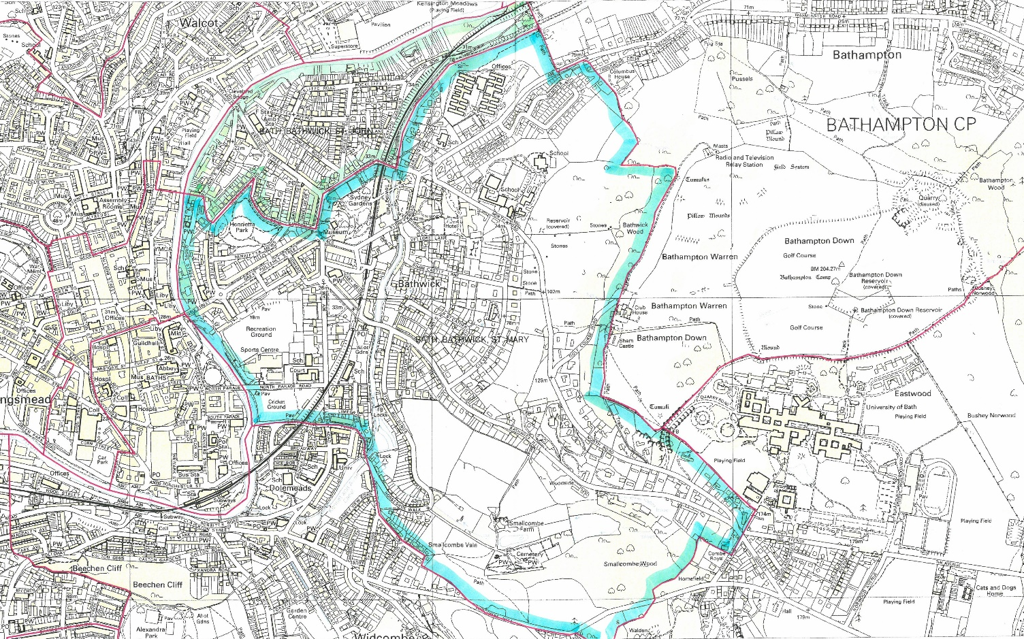

St Andrew’s Church School (2 maps)
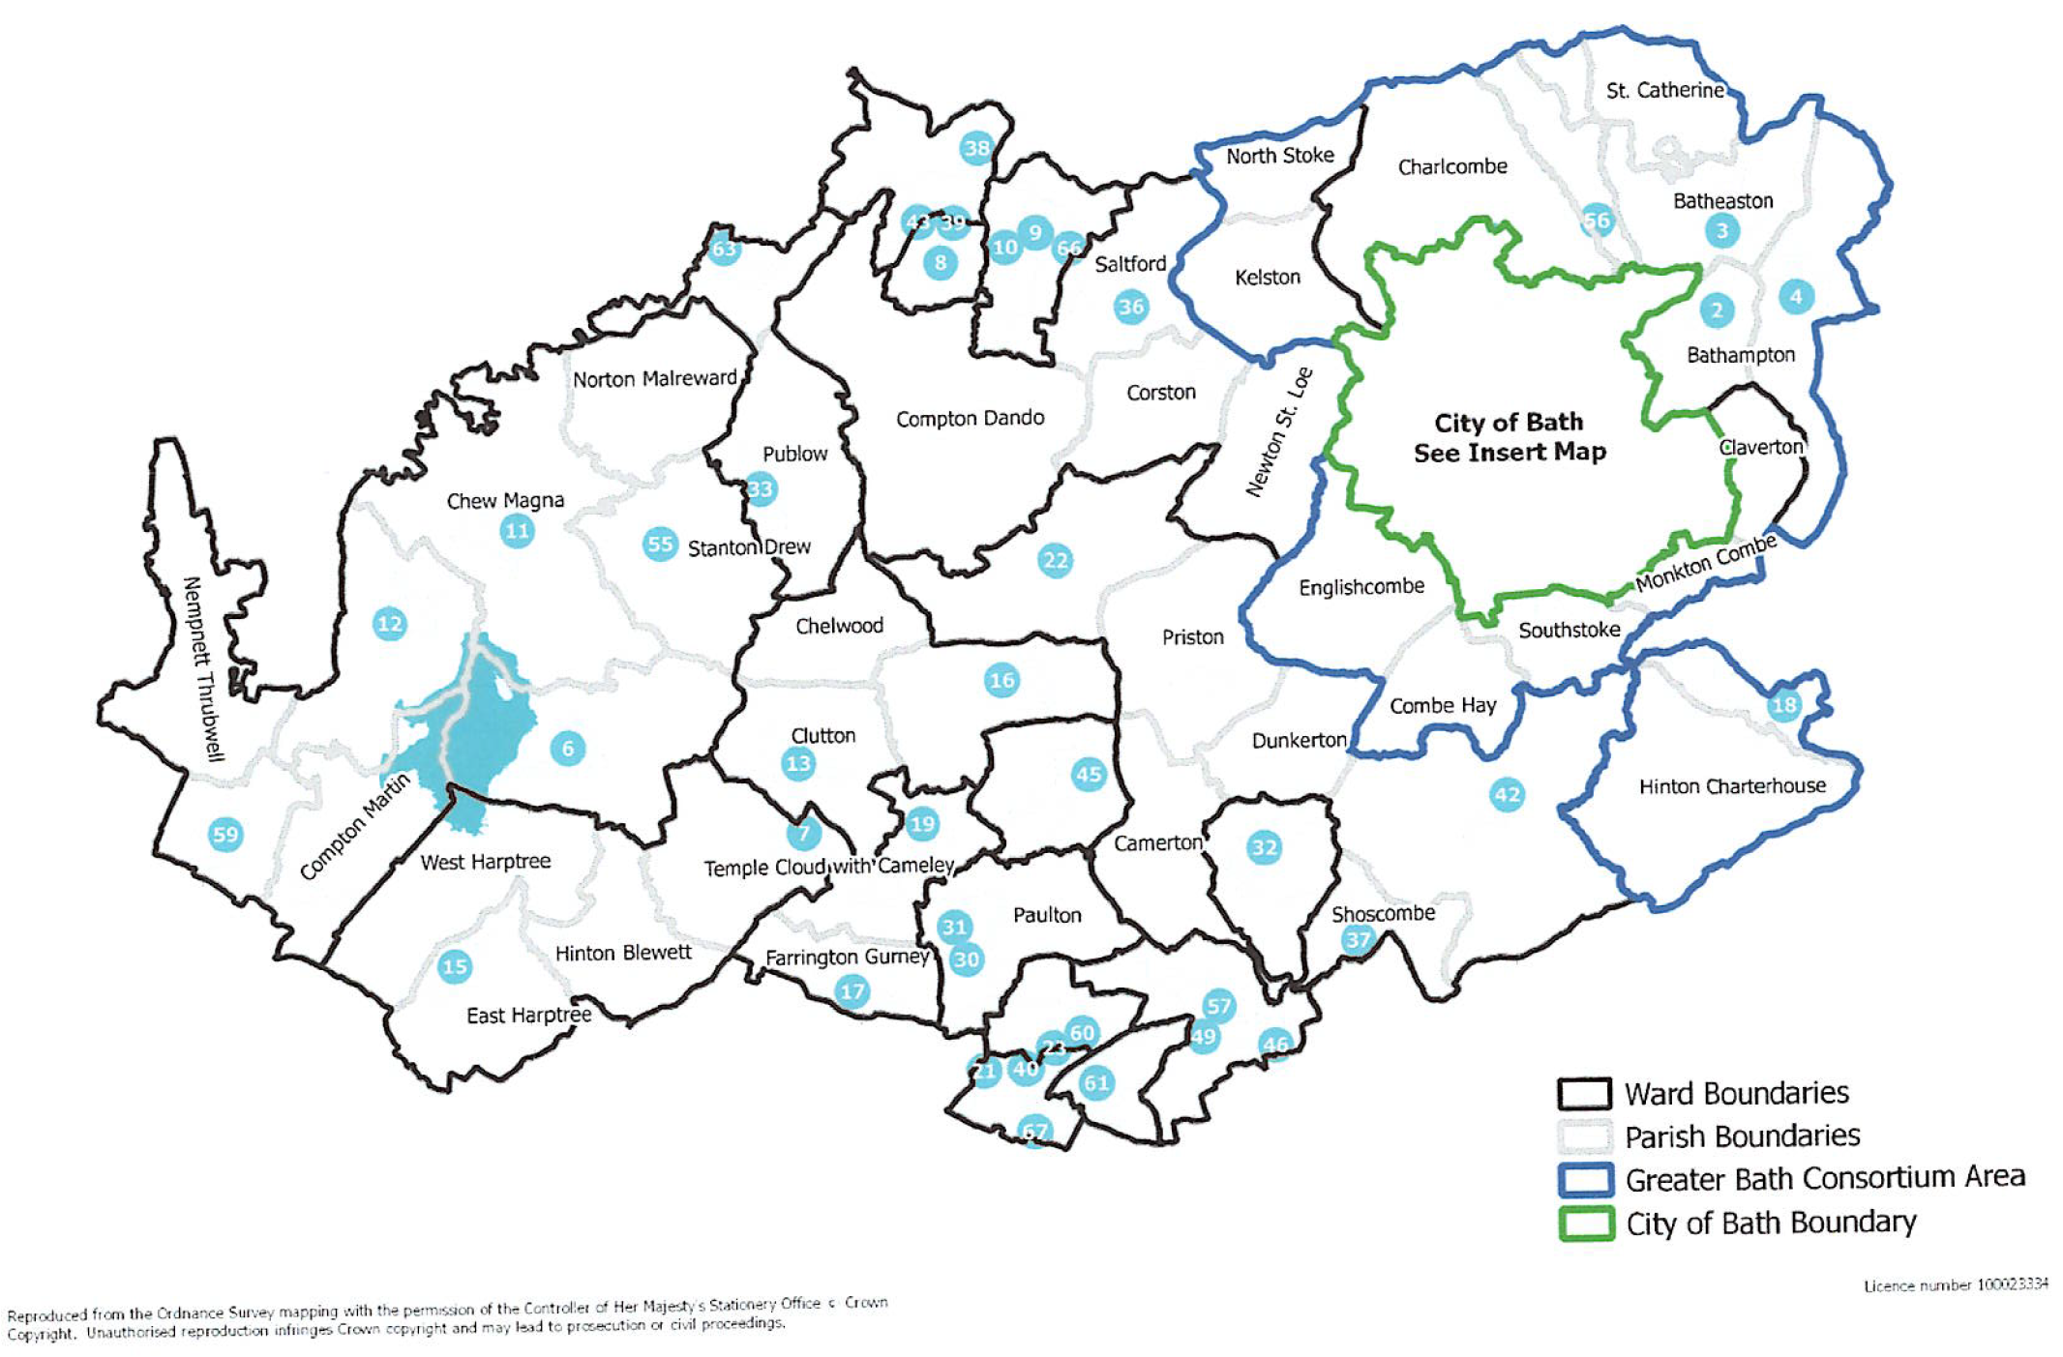
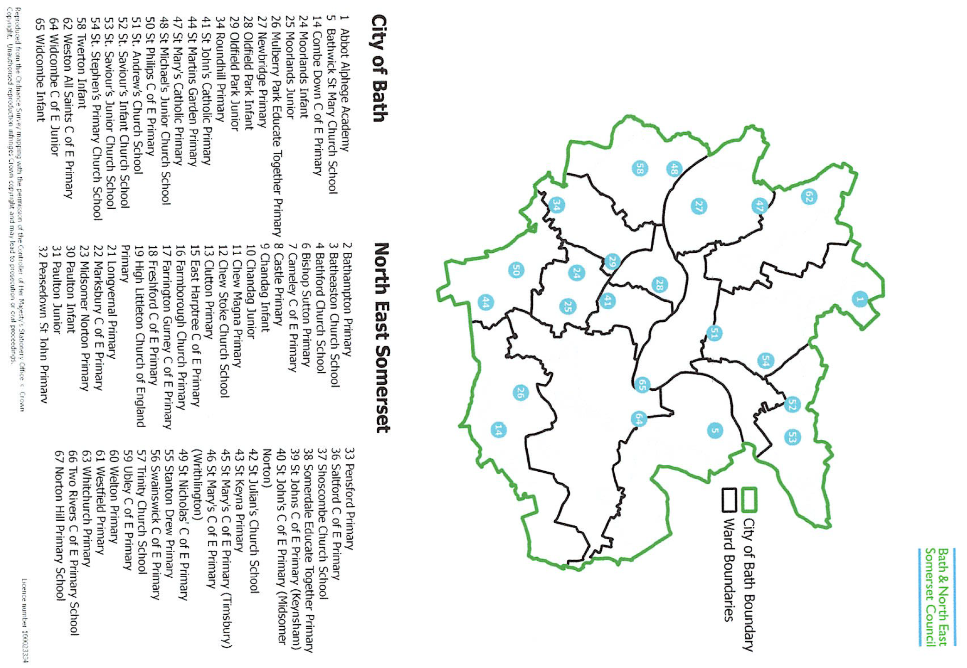

Appendix C – In Year Application Form (actual documents available on school website)

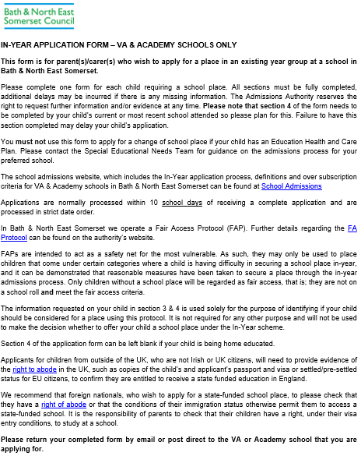

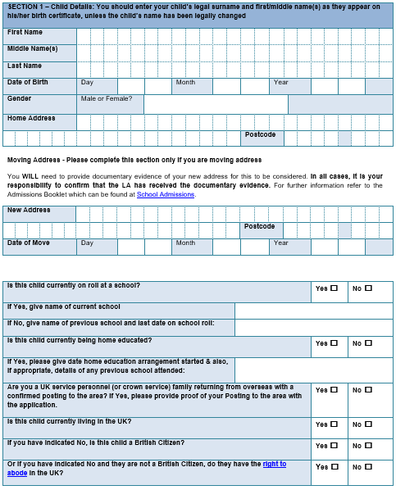

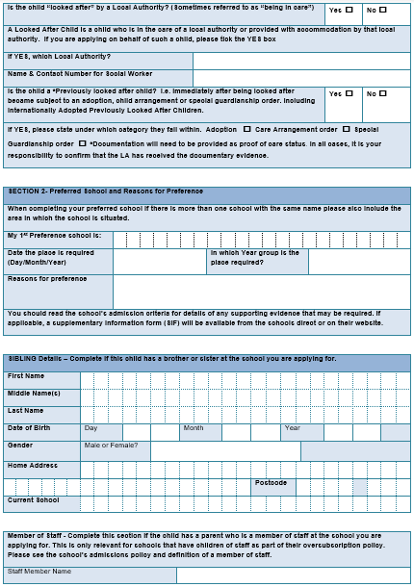

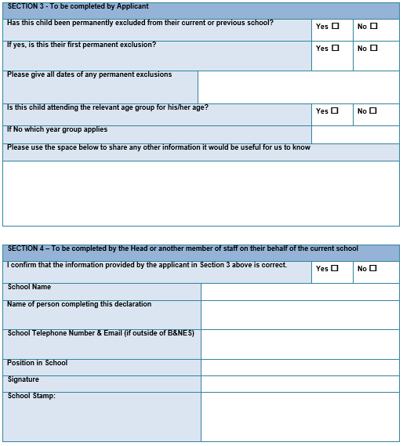

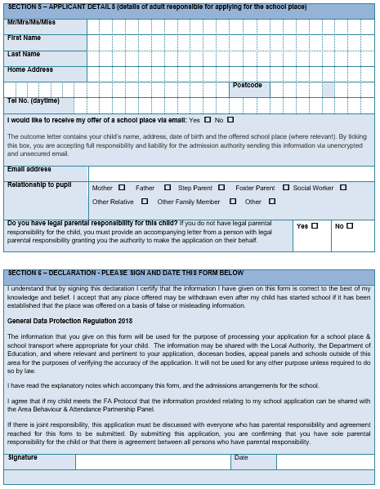

Appendix D - Supplementary Information Forms (SIF)

Supplementary Information Form (SIF) for:
Bathwick St Mary Church School

Note: The oversubscription criteria for the following Bath and Wells Multi Academy Trust schools include one or more faith criterion relating to the regular attendance at a Church or other place of worship: Bathwick St Mary Church School, Darlington Road, Bath, BA2 6NN.

This Supplementary Information Form (SIF) must be used where a parent/carer chooses to provide qualifying evidence in support of a School Admission Application for one of the above schools. In the event of the school applied for being oversubscribed with applications, the published oversubscription will be applied and all applications placed in ranked priority order. If, in these circumstances, a parent/carer would like a child in their care to be assessed against an applicable faith criterion, this SIF must be completed by the Vicar or Faith leader and signed and submitted by letter post or email directly to the school concerned before 15 January 2023. Failure to submit a completed SIF by this deadline will mean that the relative faith criterion cannot be taken into account for the child concerned when prioritising admission applications at the preferred school. Where the parent/carer wishes qualifying evidence to be taken into account for more than one of the schools named above, a separate SIF must be completed for each school.

Please be aware that if this SIF is submitted by email, this is an open platform and not encrypted and therefore yours and your child’s personal details may not be secure.

Part 1
This SIF relates to the School Admission Application Form submitted on behalf of:
Child’s DOB (date/month/year): | Child’s Full Name:
School applied for:

Part 2
Name of Vicar or Faith Leader completing this SIF (print):
Church or place of worship:
Statement:
I confirm that the child named in Part 1 of this SIF and/or their parent(s)/primary carer(s) has regularly attended a service of Christian worship at the Bathwick Parish Churches. Regular attendance is defined as ‘15 times per year for a minimum of two years’ immediately prior to the completion of this SIF and therefore qualifies the requirements of the appropriate faith criterion (criterion number: 5) contained in the Oversubscription Criteria published for the stated school.

Signed: |  | Date of signature:

Supplementary Information Form (SIF) for:
St Andrew’s Church School

Note: The oversubscription criteria for the following Bath and Wells Multi Academy Trust schools include one or more faith criterion relating to the regular attendance at a Church or other place of worship: St Andrew’s Church School, Northampton Street, Julian Road, Bath, BA1 2SN

This Supplementary Information Form (SIF) must be used where a parent/carer chooses to provide qualifying evidence in support of a School Admission Application for one of the above schools. In the event of the school applied for being oversubscribed with applications, the published oversubscription will be applied and all applications placed in ranked priority order. If, in these circumstances, a parent/carer would like a child in their care to be assessed against an applicable faith criterion, this SIF must be completed by the Vicar or Faith leader and signed and submitted by letter post or email directly to the school concerned before 15 January 2023. Failure to submit a completed SIF by this deadline will mean that the relative faith criterion cannot be taken into account for the child concerned when prioritising admission applications at the preferred school. Where the parent/carer wishes qualifying evidence to be taken into account for more than one of the schools named above, a separate SIF must be completed for each school.

Please be aware that if this SIF is submitted by email, this is an open platform and not encrypted and therefore yours and your child’s personal details may not be secure.

Part 1
This SIF relates to the School Admission Application Form submitted on behalf of:
Child’s DOB (date/month/year): | Child’s Full Name:
School applied for:

Part 2
Name of Vicar or Faith Leader completing this SIF (print):
Church or place of worship:
Statement:
I confirm that the child named in Part 1 of this SIF and their family have attended a Church service for which I am responsible at the place of worship named above, at least once a month for not less than 6 months immediately prior to the completion of this SIF and therefore qualifies the requirements of the appropriate faith criterion (criterion number: 4) contained in the Oversubscription Criteria published for the stated school.

NB In the event that during the period specified for attendance at worship the church has been closed for public worship and has not provided alternative premises for that worship, the requirements of these (admissions) arrangements in relation to attendance will only apply to the period when the church or alternative premises have been available for public worship.

Signed: |  | Date of signature:

