Swainswick Ethos Council
Meeting Records - 28.09.21

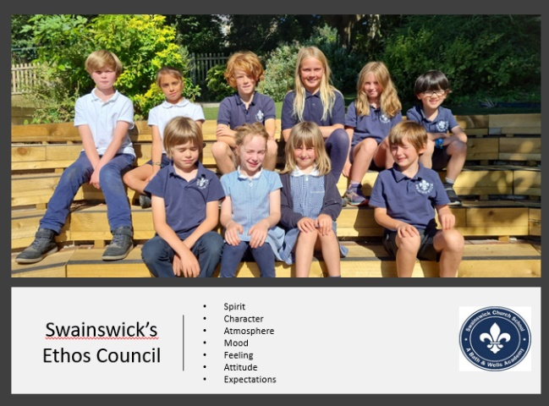  Present:  - Hughie  - Briar  - Rhoda  - Sebastian  - Jimmy  - Mireille  - Rou  - Vaila  - Osian | Topics covered on the agenda  - Safeguarding  - Collective Worship  - Harvest Festival  - Behaviour  - AOB
Decisions | Actions | Action By
- Safeguarding | - Tape off the areas where the new bees have been seen as new reception children might not be aware.  - Teach the reception children how to be aware but not afraid of the ‘Minor Bees’  - On ‘Friendship Fridays’ no football because the ball could hit a reception child.  - Check that every class has a worry box and that the children know about them – to discuss in assembly.  - Every child should have two named teachers to go to if they are worried. Those teachers will also check in on those children regularly. | Osian  Vaila  Sebastian  Rhoda  Briar and Mireille
- Collective Worship | - Rota for children to set up the reflection table  - Try and link a song to the theme  - New cloths for the class reflection table
- Harvest Festival | - Harvest Festival – meet next week to organise our Harvest Festival | Meet next week
- Behaviour | - Reminder every class to complete their ‘Expectation Photograph Slides,  - Monday’s assembly we will share across the school and link to our school value. | Rou and Hughie  Children need to report back to class about Monday’s sharing assembly
AOB: | - Our Values Posters need to be displayed and laminated outside as they are getting wet and blow away. | - Deia and Freddie

